Design a class named Box whose dimensions are integers and private to the class. The dimensions are labelled***: length*** l, ***breadth*** b, and ***height*** h.

The default constructor of the class should initialize *l, b*, and *h* to 0.

The parameterized constructor Box (int length, int breadth, int height) should initialize ***Box***’s ***l, b***, and ***h*** to l***ength, breadth*** and ***height***.

The copy constructor Box (Box B) should set ***l, b*** and ***h*** to ***B***’s ***l, b*** and **h**, respectively.

Apart from the above, the class should have 4 functions:

* Int getLength() – Return Box’s length
* Int getBreadth() – Return box’s breadth
* Int getHeight() – Return box’s height
* Long long CalculateVolume() – Return the volume of the box

Overload the operator < for the class Box. Box **A** < Box **B** if:

1. ***A.l < B.l***
2. ***A.b < B.b*** and ***A.l == B.l***
3. ***A.h < B.h*** and ***A.b == B.b*** and ***A.l == B.l***

Overload operator << for the class Box().

If **B** is an object of class Box:

***Cout << B*** should print **B.l, B.b** and **B.h** on a single line separated by spaces.

For example,

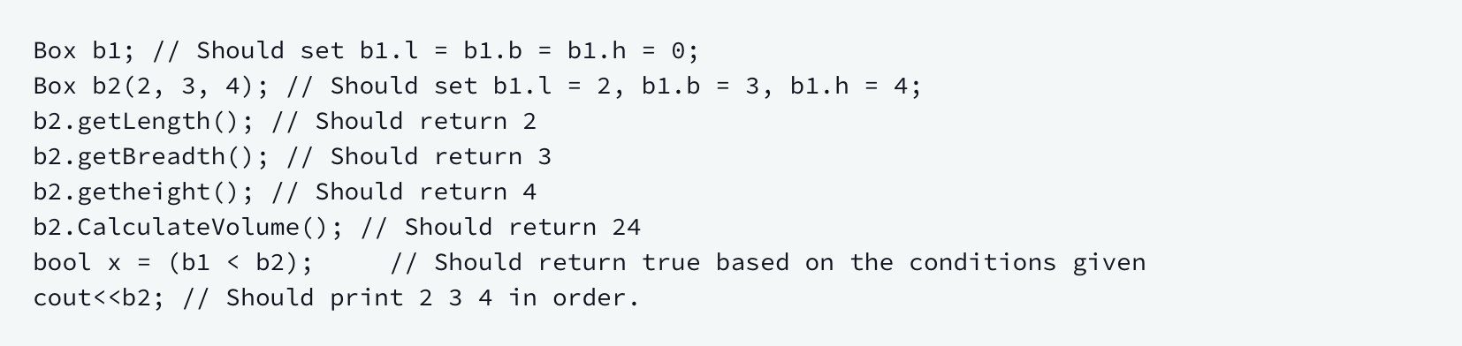

**Constrains**

0 <= l, b, h <= 10^5

Two boxes being compared using the < operator will not have all three dimensions equal.